**Category**- Guest Post

**Main Keyword**: Restore Shift Deleted Items in Outlook 2010|2013|2016

**Keywords**

**recover shift deleted files, recover shift deleted emails from outlook 2010, repair outlook file**, **fix outlook error**, **fix outlook file corrupted**

**Learn How to Restore Shift Deleted Items in Outlook 2010/ 2013/ 2016**

Microsoft Outlook offers good personal information management of all important emails, events, and note at one place. Data is adequately managed through sorting, and deleting emails, contacts or events in an Outlook. It also comes with a feature to recover any deleted item. Deleted items can be moved back from the Deleted Items folder. All such temporary deleted Outlook items can be recovered in a few simple steps, but sometimes, there is a need to recover permanently deleted Outlook items. At a cursory glance, it may appear that such recovery is impossible, but this article will discuss the method and tools that will help you restore shift deleted files.

**Reasons of Permanent Deletion in Outlook**

It is a requirement that deleted files be recovered at a later time. Even though removal of such files or folders was crucial at the time. Confidential emails like card details and banking credentials have to be deleted from the server for security purposes. Accidental deletion is also very common with the sheer amount of data that comes under Outlook management. It has also been observed that data is deleted due to a corrupted Outlook file. When the data is lost, we search far and wide to find a simple solution to recover shift deleted emails from outlook 2010.

**Note:**

* Shift deletion (Shift+Del) in MS Outlook causes the folder/contacts to be deleted forever.
* Deleting files from the Deleted Items folder.
* While using an IMAP4 or other clients that do not move the removed file to a Deleted folder.

Usually, when items are deleted from Outlook, they go to the Deleted Items folder. They can be recovered by restoring them, which is known as Soft Delete. Other times, an item is permanently deleted. It cannot be moved back with a few steps. However, Outlook has a hidden Recover Deleted Items folder which could help in bringing back our shift deleted files.

**Methods To Restore Shift Deleted Items in Outlook**

This section elaborates the manual methods that you can follow to try and restore shift deleted files if you are using Outlook 2010, 2013 and 2016. The first method is Outlook’s own Recovery method, and the second uses Outlook Web Access. They are detailed as follows.

**Solution 1- Outlook Recovery Process for Shift Deleted Files**

This is the first solution for recovering items through Outlook itself.

**Tip:** Always remember to obtain a backup of your data before performing any recovery operation. Following are the steps to recover your data using the Recover Deleted Items folder:

1. In MS Outlook, click ***Folder*** >> ‘***Recover Deleted Items’***.

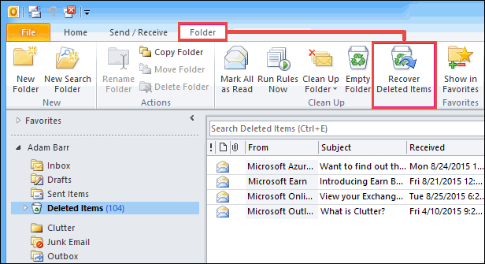

1. Find and mark the item(s) that you want to recover and click on ‘***Recover Selected Items’*** from the top menu.

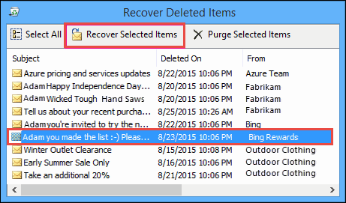

**Tip:** If the Recover Deleted Items folder contains a lot of mails, you can refine your search. Sort by clicking on Column names ‘Deleted On’, ‘Subject’ or ‘From’. The mail is sorted by the date when it was permanently deleted when using the ‘Deleted On’ sorting.

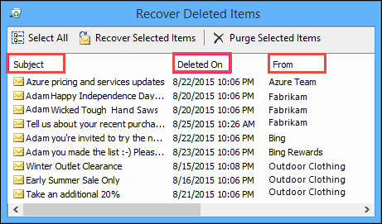

**Note**: Recovered items from the Recoverable Items folder go to the Deleted Items folder. So after an item is recovered, you can move it from **Deleted Items** to any other folder. The same is true for Contacts, Calendar and Outlook Tasks.

**Option-2 Outlook Web Access Option**

You can also try to recover your items using the Outlook Web Access using Exchange 2003 because it doesn’t need you to have a registry key.

1. Recovery of only Public Folders from mailbox can be achieved through the URL

***http://servername/exchange/alias/inbox/?cmd=showdeleted***

Login with your account and permit the ‘Full mailbox access’. From the list of deleted items, select all files you want to recover.

1. To recover Public Folder items, the URL will be ***http://servername/public/rootfolder/subfolder/?cmd=showdeleted***

“servername:” Exchange server's name.

“path”: path to the parent of deleted folder.

Select the deleted folder and recover it. Remember to always close your browser and OWA after this to protect sensitive information.

**Limitations of the Manual Approach**

* If the administrator has not configured Exchange Server settings, the Recover Deleted Items functionality will not be available by default for any folders in Outlook.
* Without a registry key (Dumpster.reg), the Web Access method will not be able to recover private folders.
* There is a retention period for deleted items, after which that not recoverable. But, if you have been unsuccessful in finding the requested Contact/File, then they have been deleted forever.
* The manual approach would still not be able to fix Outlook error that caused Contact or email files and folders to be inaccessible.

The most appropriate solution would be to use a dedicated tool that can restore permanently deleted files and repair Outlook file for a complete problem resolution.

**Reliable Outlook Recovery Tool**

The manual recovery of permanently deleted Outlook files is time-consuming and often unsuccessful. However, there is an **Outlook Recovery Tool** that is adept at file recovery. This automated tool can restore Contacts, Emails or folders even though it is past their retention period. Let’s look at some of the attributes of the Outlook Recovery Tool:

* **Recover deleted data**: Using this tool, users can restore the shift deleted emails or other files. Moreover, the tool allows the user to recover deleted items from a corrupt .pst file using Advance Scan.
* **Export recovered data in multiple formats**: The tool gives the user an option to save the recovered Outlook file in the file format of their choosing. It can be either .pst, .eml or .msg depending on their needs and requirement. Using Mail Filter, you can select emails from one date to another.

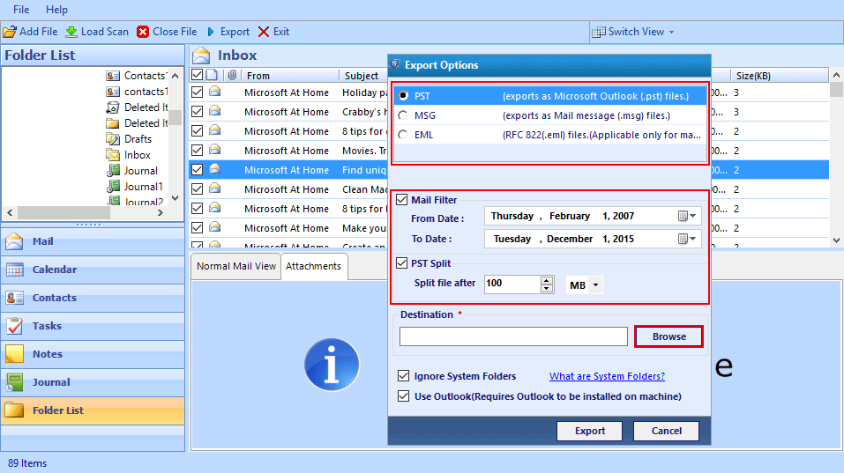

* **Split resulting file into smaller PST:** The larger files are split into smaller .pst files for ease of access. The user can specify in MBs the size according to which the split is required.
* **Ensures data integrity:** When Outlook folders and files are restored, they maintain their integrity. They are recovered as is, without any data loss.

This is what makes the tool indispensable for any user looking to recover permanently deleted data. It is quick, efficient, and complete in itself. It can become your go-to procedure for swiftly restoring deleted data.

**Conclusion**

This article explains the various manual methods to restore shift deleted items in Outlook 2010, 2013 and 2016. Since the manual method is long and procedure oriented, there is a great need for a simple tool like the Outlook Recovery Tool which can adeptly handle all your recovery needs. The tool is a well-rounded application that can also fix Outlook error and takes you through the recovery process stress-free. If you face any issues during the restore process, you can leave a comment with your query and we will respond with a solution.